Algebra 3-4 Name: __________________
Ch. 4 Review Packet Date: ___________________

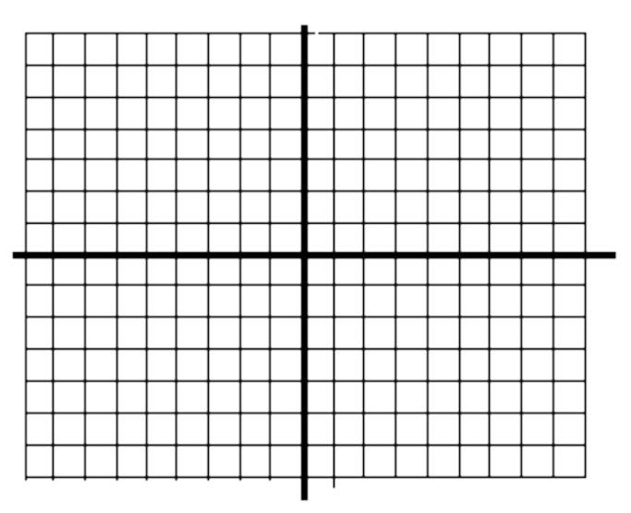
Graph the quadratic function. Label the vertex and axis of symmetry.

1. y = - x² + 4x + 7

Vertex: __________

Axis: ___________

2. y = 3(x – 2)² - 5

Vertex: __________

Axis: ____________

3. 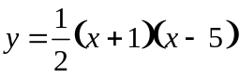

Vertex: ___________

Axis: ____________

Write the quadratic function in standard form and identify the vertex.

4. y = 4(x – 3)² – 7 5. y = (2x + 2)(x – 5)

Write the quadratic function in intercept form and identify the vertex.

6. y = x² – x – 20 7. y = 9x² + 6x + 1

Write the quadratic function in vertex form and identify the vertex.

8. y = x² – 8x + 17

9. y = -x² – 2x – 6

10. 4x² + 16x + 23

Graph the quadratic equation.

11. y ≥ x² – 4x + 4

12. y < x² + 6x + 5

13. y > -2x² + 3

Solve the quadratic inequality.

14. x² – 3x – 4 ≤ 0

15. 2x² + 7x + 2 ≥ 0

16. 9x² > 49

